Palo Alto URL Filtering and Override

Reed Holman |Cisco Cyber Security | 10/10/2022

**Purpose:**

The point of this lab was to get the firewall to deny access to certain websites and to allow the use of a password to override that filter.

**Background Information**:

One of the main purposes of a firewall is security. This can be in the form of preventing harmful attacks. It can also be in preventing your devices from access dangerous websites or in some cases distracting websites. An effective way of doing this is to set up URL filtering which can block user access to specific websites.

**Lab Summary:**

We configured a Palo Alto firewall to block a specific category of websites and to give us an option to go to those websites with a password.

**Configurations:**

Step 1: Click Network Tab, Then URL Filtering. (Check Default to see what is already blocked) 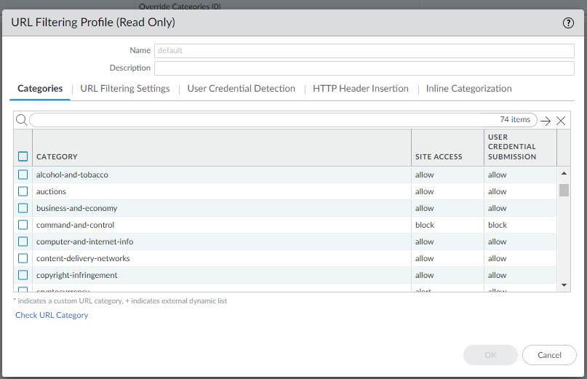

Step 2: Create a new Filtering Profile. Give it a name and select which categories to block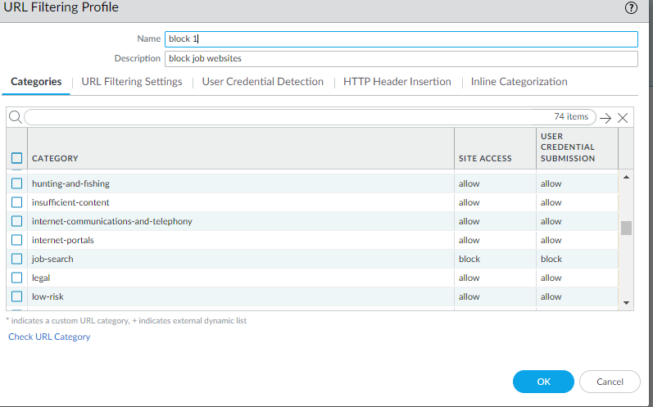  
Step 3: Go to the polices, then security and finally click on internet outgoing. Go to the actions setting and under URL filtering apply the new profile we just created

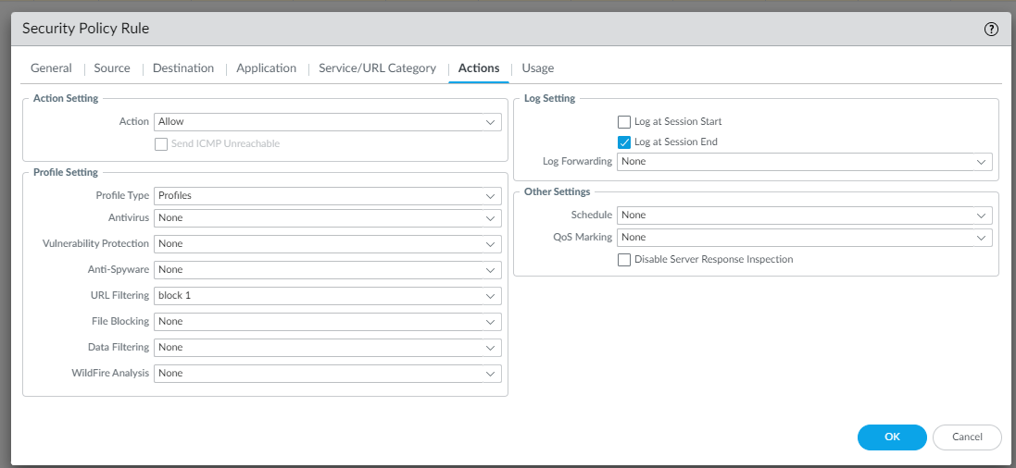

Step 4: Click on device, then on certificates. In the bottom left select generate new certificate.

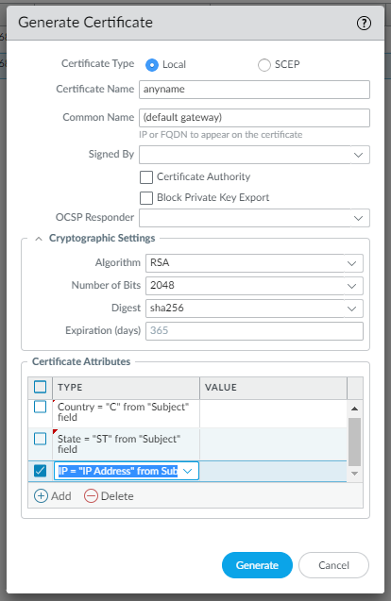  
^^^ (cool configuration to use) ^^^

Step 5: Go to network tab, then interface management and add a new profile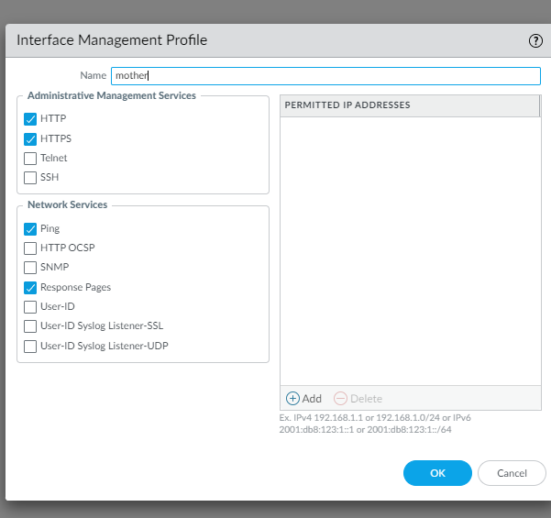

^ (click these things)

Step 6: Go to network tab, interface > ethernet. On the layer 3 interface clicked advanced and apply the new profile we just created

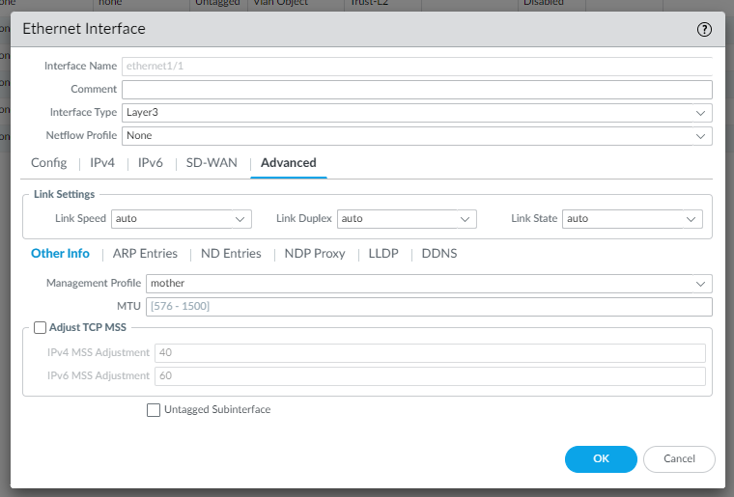

**Problems:**

We wasted time with the response pages tab because we believed it would be necessary, but it turned out it was not needed. The thing we forgot to do was configure an Interface Management Profile and once we did that our firewall was able to block the websites we wanted.

**Conclusion:**

We were able to configure a Palo Alto firewall with the ability to filter a specific group of websites and the ability to override that with a password.